CHAPTER 1
INTRODUCTION
The growing reliance on digital credentials has highlighted significant challenges with traditional paper-based and centralized certificate systems, which are often susceptible to forgery, tampering, loss, and time-consuming verification procedures. To overcome these limitations, this project introduces a Block chain based Digital Certificate Generation and Verification System designed to ensure secure, transparent, and tamper-proof credential management. By leveraging blockchain’s decentralized and immutable architecture, the system enables institutions to issue certificates that cannot be altered, while providing recipients with easy access and shareability of their digital credentials. Verification authorities and employers can instantly validate certificate authenticity without intermediaries, resulting in faster processing, reduced fraud, and improved trust in credential management processes..
  - Domain Description
The domain of blockchain focuses on developing decentralized, transparent, and tamper-proof data management systems, making it highly suitable for applications that require strong security, trust, and immutability. In the context of this project, blockchain serves as the core technology for securely generating, storing, and verifying digital certificates without relying on a central authority. Its distributed ledger architecture ensures that every certificate issued is permanently recorded, verifiable, and protected against unauthorized modifications or duplication. Smart contracts automate certificate issuance and validation processes, reducing manual intervention and eliminating fraud risks. By utilizing blockchain, the project ensures long-term integrity, transparency, and trustworthiness of credential management, making the entire certificate lifecycle—from creation to verification—efficient, secure, and fully auditable.
1.2 About the Project
This project focuses on building a secure and transparent Blockchain-based
Digital Certificate Generation and Verification System that addresses the common issues of forgery, tampering, and delayed verification found in traditional certificate management. The system allows educational institutions and organizations to generate digital certificates and store them on a blockchain ledger, ensuring permanent, tamper-proof records. Using smart contracts, certificates are automatically validated and can be accessed or shared by recipients at any time. Employers and verification authorities can instantly authenticate the credentials without manual checks or intermediaries, significantly improving efficiency and trust. Overall, the project delivers a modern, decentralized solution that enhances security, speeds up verification, and provides a seamless, user-friendly experience for all stakeholders involved in the certification process.
Beyond ensuring secure certificate management, the project also focuses on improving scalability, accessibility, and user experience across all roles in the system. A simple web-based interface allows institutions to upload certificate data, which is then encoded and deployed onto the blockchain with minimal technical complexity. Recipients can log in to view, download, or share their certificates, while verifiers can authenticate them by simply scanning a QR code or entering a certificate ID. The system’s decentralized design eliminates dependency on any single server, reducing downtime and enhancing reliability. By integrating blockchain with modern web technologies, the project creates a future-ready platform that can be adopted by universities, training centers, and professional organizations to maintain trust, transparency, and efficiency in digital credential management.

CHAPTER 2
LITERATURE SURVEY
2.1 Nguyen et al. (2016) — Blockchain for Academic Records
The study explored the feasibility of recording academic transcripts on a public blockchain. The authors designed a prototype that hashes certificate metadata and anchors those hashes in blockchain transactions to provide tamper-evident records; they demonstrated simple verification flows for third parties by re-hashing presented documents and comparing anchors on-chain. Their work highlighted clear improvements in auditability and immutability compared to paper or centralized DB approaches.
However, the prototype relied on storing only small hashes on a public ledger and used off-chain storage without standardized retrieval or access controls, creating usability and privacy concerns. This motivated systems that integrate secure off chain storage (e.g., IPFS or encrypted cloud) with standardized verifiable credential formats and managed access controls so certificate holders can share credentials while preserving privacy.
2.2 Alford & Chen (2017) — Smart Contracts for Degree Issuance
This paper implemented Ethereum smart contracts to automate degree issuance and revocation. The smart-contract logic encoded issuance policies, issuer identities, and a simple revocation flag, enabling immediate public verification of certificate status via blockchain queries. The contribution demonstrated how programmable contracts can reduce manual verification labor and enforce issuance rules automatically.
However, transaction costs and latency on public blockchains impacted scalability and practical throughput for large educational systems. The work motivates exploring permissioned ledgers or layer-2 solutions and hybrid designs that keep verification trustworthy while minimizing cost and improving transaction speed.
2.3 García et al. (2018) — Decentralized Identifiers (DIDs) for Students
The authors investigated using Decentralized Identifiers (DIDs) as a privacy preserving identity layer for learners. They demonstrated DID creation, issuer controlled credential attachment, and selective disclosure mechanisms that allow learners to present identity-linked claims without exposing unnecessary personal data.
The study emphasized user control and portability of credentials across institutions.
However, early DID implementations lacked interoperability standards and mature user wallets, making widespread adoption difficult. This gap motivates integrating recognized standards (W3C Verifiable Credentials, interoperable DID methods) and providing user-friendly wallets and UX for certificate holders.
2.4 Kumar et al. (2018) — IPFS + Blockchain for Certificate Storage
This work proposed storing certificate files in IPFS and anchoring content identifiers (CIDs) on-chain for integrity verification. The architecture separated storage from proof-of-authenticity, reducing on-chain storage needs while enabling content retrieval via IPFS gateways. The paper showed substantial on-chain cost savings and improved data availability compared to storing files directly on-chain. However, IPFS's content persistence depends on pinning strategies and third-party nodes; without robust pinning, certificates risk becoming unavailable. The limitation drives designs that combine decentralized storage with institutional pinning services or redundant backups and user-accessible retrieval guarantees.
2.5 Singh & Patel (2019) — Permissioned Ledger for University Consortiums
The authors developed a permissioned blockchain (Hyperledger Fabric) for a consortium of universities to exchange and verify credentials. The system offered access control, fine-grained permissioning, and private channels for institutional data sharing, addressing legal and privacy constraints between partners. The study demonstrated improved governance and audit trails suited to institutional contexts.
However, permissioned networks require governance agreements and ongoing trust among participants, which can be administratively heavy and slow to onboard. This motivates building modular governance frameworks, clear onboarding policies, and hybrid models that allow public verifiability for certificates while keeping sensitive metadata in private channels.
2.6 Romero et al. (2019) — Revocation Mechanisms for On-Chain
Certificates
This research examined revocation models for blockchain-stamped credentials, comparing on-chain revocation lists, revocation registries, and short-lived tokens. The authors proposed a revocation registry pattern that efficiently marks certificates as revoked without rewriting historical anchors, enabling verifiers to check current validity status. The contribution targeted realistic lifecycle management for digital credentials.
However, revocation registries can introduce lookup complexity and depend on registry availability or synchronization. The study motivates combining cryptographic accumulator-based revocation or OCSP-like online checks with offline-verifiable proofs to support both instant checks and offline validation.
2.7 Johnson et al. (2020) — Privacy-Preserving Credential Verification (zk-SNARKs)
This paper experimented with zero-knowledge proofs (zk-SNARKs) to allow verifiers to confirm credential assertions (e.g., degree or grade thresholds) without revealing the full certificate. The approach showed that selective disclosure with cryptographic proofs can preserve privacy while maintaining trust. The research advanced ways to share only necessary attributes during verification.
However, zk-solutions introduced high computational overhead and complex prover workflows, making them challenging for low-resource clients. This gap encourages exploring efficient zero-knowledge schemes, pre-computation, or hybrid privacy methods that balance proof size, verifier cost, and user convenience.
2.8 Lee & Park (2020) — Interoperability across Credential Systems
The authors analyzed cross-platform verification challenges and proposed an adapter layer translating between different credential standards and ledger formats. They provided mapping strategies between legacy PDFs, LMS exports, and verifiable credentials, enabling heterogeneous systems to interoperate. The study emphasized the need for middleware to bridge institutional systems and modern decentralized credentials.
However, adapter approaches can create centralization points and latent translation errors. This motivates adopting standard native credential formats (W3C VC) and promoting direct issuer support for interoperable exports, reducing reliance on brittle translation layers.
2.9 Wang et al. (2020) — UX and Wallet Usability for Students
This usability study tested student interactions with blockchain wallets used for storing and sharing academic credentials. Findings revealed major UX hurdles: key management anxiety, poor recovery flows, and confusion about sharing controls. The paper recommended simplified key backup methods, custodial options, and clear consent UIs to boost adoption.
However, suggested custodial compromises reintroduce centralization and trust concerns. This limitation motivates hybrid UX solutions (social recovery, institutional guardianship, user education) that preserve user control while providing practical recovery and support mechanisms.
2.10 Oliveira et al. (2021) — Scalability Analysis for Nation-Scale Deployment
The paper modeled transaction throughput requirements for a national credentialing system and evaluated several blockchain platforms under load. It quantified costs, latency, and storage trade-offs, concluding that layer-2 batching and permissioned ledgers are necessary for cost-effective nation-scale adoption. The work provided pragmatic scalability engineering guidance.
However, the study assumed idealized network conditions and did not fully address cross-border interoperability or legal constraints. This motivates flexible multilayer architectures that can adapt ledger choice based on jurisdictional and cost requirements and include cross-chain verification bridges.
2.11 Abbas & Malik (2021) — Legal and Regulatory Considerations
(GDPR)
This legal-focused research examined how immutable ledgers interact with data protection laws (e.g., the “right to be forgotten”). The authors recommended storing only hashes and pointers on-chain while keeping personal data off-chain under
controlled deletion policies to align with regulations. The paper gave governance and
compliance best practices for credential systems.
However, pseudonymized hashes can still be re-identifiable when combined with auxiliary data, and their recommendations require robust off-chain deletion and access control enforcement. This limitation motivates strict data minimization, encryption, consent management, and auditable off-chain governance in certificate systems.
2.12 Fernandez et al. (2021) — Verifiable Credentials (W3C) in
Education
This implementation study adopted W3C Verifiable Credentials to represent diplomas and transcripts, showing how standardized schemas and JSON-LD signatures enable interoperable verification across platforms. They demonstrated practical issuance, holder-controlled presentation, and verifier flows using existing libraries. The study underscored the benefits of standardization for portability. However, real-world institutions struggled with schema design, mapping legacy data, and training staff to issue VCs correctly. The challenges motivate tooling that simplifies schema creation, automates legacy data conversion, and provides institutional onboarding support.
2.13 Rossi & Bianchi (2022) — Auditability and Anti-Fraud Analytics
This paper developed analytics for detecting anomalous issuance patterns and potential fraud across a blockchain-backed credential corpus. By combining onchain metadata with issuance logs, they built heuristics and ML models to flag suspicious clusters for human review. The contribution showed how blockchain transparency enables large-scale anti-fraud monitoring.
However, analytics relying on metadata risk false positives and may expose sensitive patterns; moreover, sophisticated adversaries can attempt to mimic benign issuance flows. This motivates combining analytics with governance controls, issuer attestation, and identity verification to reduce false positives and better attribute fraud.
2.14 Nakamoto & Singh (2022) — Cost Optimization via Merkle Trees and
Batching
The authors proposed batching multiple certificate hashes into a single Merkle root per block to minimize per-certificate on-chain footprint and costs. Verifiers could still check
leaf proofs to validate individual certificates while the ledger stored compact aggregated anchors. This design reduced transaction counts and made the system more economical.
However, batching introduces challenges for immediate single-certificate
revocation and real-time visibility unless additional revocation layers exist. The limitation encourages supplementing Merkle-batching with efficient revocation registries or periodic delta updates to balance cost and real-time requirements.
2.15 Duarte et al. (2022) — Cross-Institution Trust Frameworks
This study designed a trust framework where universities mutually attest to the authenticity of each other’s issuers via a governance smart contract. The consortium approach simplified verification for employers within the network and established onboarding policies and dispute-resolution mechanisms. The framework targeted realworld trust and legal interoperability.
However, the model’s effectiveness depended on pre-existing institutional trust and formal agreements, limiting applicability to wider ecosystems with diverse stakeholders. This motivates layered trust models where public anchors and reputation systems complement consortium attestations to broaden verifiability.
2.16 Park et al. (2023) — Mobile-First Credential Wallets and Offline
Verification
This implementation built a mobile credential wallet enabling offline QR-based verification using embedded proofs and cached issuer public keys. The system allowed verifiers to validate credentials without live network access, important for areas with limited connectivity. The work improved accessibility and practical utility of digital certificates.
However, offline verification requires careful key rotation, cache invalidation, and secure local storage; stale caches can cause false validations. This gap motivates secure cache refresh protocols, short-lived attestations, and hybrid online-offline checks to maintain security while enabling offline use.
2.17 Zhang & Li (2023) — Multi-Authority Issuance and Delegation
The authors introduced a multi-authority issuance model where an institution can delegate issuance rights to departments or faculty via on-chain delegated keys and role-
based smart contracts. This enabled distributed issuance while preserving central auditability and made cross-department credentialing scalable. The contribution improved operational flexibility.
However, delegation increases the attack surface and complicates revocation if delegated keys are compromised. The study motivates robust key management, threshold signatures, and clear delegation/revocation flows to preserve security under distributed issuance.
2.18 O’Connor et al. (2023) — International Credential Portability and Translation
This research focused on translating credential attributes across national qualification frameworks using standardized mappings and verification APIs. They proposed embedding qualification metadata with issuance proofs so foreign verifiers can programmatically interpret credentials. The approach aimed to streamline international hiring and academic mobility.
However, mapping across frameworks is intellectually and politically complex; automated translations can be contested and require human adjudication in ambiguous cases. This motivates preserving human-readable evidence and audit trails while using standardized metadata to inform—but not replace—human decision-making.
2.19 Ibrahim & Gomez (2024) — Security Hardening Against KeyTheft and
Phishing
The paper analyzed attack vectors against holder wallets and issuer key compromise, recommending multi-factor signing, threshold HSMs for issuers, and social recovery for holders. They also proposed issuer attestation checks to detect anomalous issuance originating from compromised keys. The study advanced operational security practices for credential ecosystems.
However, advanced protections raise cost and complexity for small institutions; HSMs and threshold schemes may be out of reach for some issuers. This limitation motivates offering tiered security services—managed HSMs or custody alternatives— so smaller institutions can adopt strong security affordably.
2.20 Silva et al. (2024) — End-to-End Certificate Lifecycle Framework
This recent work proposed a complete lifecycle architecture that covers issuance, holder-controlled storage, selective disclosure, revocation, portability, and analytics driven fraud detection. The authors integrated W3C VCs, DIDs, IPFS for storage, Merkle batching, and a revocation registry, supported by governance modules for issuer onboarding and compliance. The study presented a practical blueprint for production-ready deployments.

CHAPTER 3
SYSTEM ANALYSIS
System Analysis is a process of collecting and interpreting facts, identifying the problems, and decomposition of a system into its components.
System analysis is conducted for the purpose of studying a system or its parts in order to identify its objectives. It is a problem solving technique that improves the system and ensures that all the components of the system work efficiently to accomplish their purpose. Analysis specifies what the system should do.
The module simply means the software components that are been created by dividing the software. The software is divided into various components that work together to form a single functioning item but sometimes they can perform as a complete function if not connected with each other. This process of creating software modules is known as Modularity in software engineering.
3.1 Problem Statement
Traditional certificate management systems—whether paper-based or centralized digital platforms—continue to suffer from major security, authenticity, and verification challenges. Paper certificates are highly vulnerable to loss, damage, forgery, and duplication, while centralized digital systems face risks such as data tampering, hacking, unauthorized modification, and single-point failures. Verification in current systems is slow, heavily manual, and dependent on institutional intermediaries, causing delays for students, employers, and verification authorities. Furthermore, the lack of transparency, traceability, and real-time authentication erodes trust and leads to administrative inefficiencies.
Existing digital certificate solutions also fail to ensure long-term data integrity or provide decentralized, tamper-proof verification mechanisms. They typically rely on conventional databases that do not offer immutability, distributed trust, or auditable transaction logs. As a result, organizations struggle to maintain secure credential records, while users lack a reliable method to share or verify certificates instantly. These limitations collectively highlight the need for a modern, secure, and decentralized framework that guarantees authenticity, prevents fraud, and enables instant certificate verification without intermediaries. Therefore, a blockchainbased certificate generation and verification system is required to ensure immutability, transparency, and trust across all stakeholders in the credentialing ecosystem.
3.2 Problem Description
In traditional certificate systems, institutions issue paper-based or centrally stored digital certificates that are highly vulnerable to forgery, unauthorized alterations, and data breaches. Paper documents can be easily manipulated or duplicated, and they deteriorate over time, making them unreliable for long-term verification. Digital certificates stored in centralized servers are also at risk of hacking, system failures, insider attacks, and accidental data loss. Since these systems do not provide immutable records, verifying authenticity often requires manual cross-checking, institutional approval, or communication between multiple departments—leading to significant delays and inefficiencies.
Moreover, verification authorities and employers face the challenge of validating certificates without a trusted, unified, or automated verification mechanism. The absence of real-time, tamper-proof validation increases the risk of accepting fraudulent credentials. Centralized systems also lack transparency and auditability, making it difficult to track certificate issuance history or detect misuse. Users, on the other hand, often struggle with accessibility, portability, and secure sharing of their credentials. These issues collectively necessitate a decentralized, secure, and scalable system that leverages blockchain’s immutability, distributed consensus, and cryptographic verification to ensure trustworthy certificate management. Such a system must eliminate fraud, support instant verification, reduce administrative burden, and enhance trust among institutions, users, and employers.
3.3 Existing System
The existing certificate management systems primarily rely on paper-based documents or centralized digital storage platforms, both of which suffer from significant limitations in terms of security, transparency, and verification efficiency. Paper certificates are vulnerable to damage, loss, duplication, and forgery, making them unreliable for long-term authentication. Centralized digital systems, while more accessible, still pose risks such as data tampering, unauthorized access, single points of failure, and limited traceability. Verification processes in these systems are often manual, time-consuming, and dependent on intermediaries, leading to administrative delays and increased operational costs. Additionally, users and employers struggle with the lack of a unified platform for real-time verification, resulting in trust issues and inefficiencies. These drawbacks highlight the need for a more secure, decentralized, and tamper-proof solution for issuing and validating certificates.
3.4 Disadvantages of Existing System
Paper and centralized digital certificates can be easily manipulated, duplicated, or counterfeited, leading to credibility issues.
Centralized Database Vulnerability
Traditional digital systems rely on a single central server, making them prone to hacking, data breaches, and single points of failure.
Time-Consuming Verification Process
Verification often requires manual checking by institutions, causing delays for students, organizations, and employers.
Lack of Transparency and Traceability
Existing systems do not offer a transparent audit trail, making it difficult to track certificate history or verify authenticity instantly.
Risk of Loss or Damage
Physical certificates can easily be lost, misplaced, or damaged, requiring re-issue and additional administrative effort.
Dependence on Intermediaries
Users rely on issuing institutions for verification, creating bottlenecks and increasing administrative workload.
Low Accessibility and Portability
Physical certificates and offline verification processes make it difficult for recipients to share or access their credentials anytime, anywhere.

Inefficient Record Management
Institutions face challenges in securely storing, retrieving, and maintaining large volumes of certificates over time.
No Real-Time Verification
Employers and authorities cannot instantly check validity, leading to delays in recruitment or admission processes.
3.5 Proposed System
The proposed system is a Blockchain-based Digital Certificate Generation and Verification System designed to overcome the limitations of traditional paper-based and centralized digital certificate systems. The system leverages the decentralized, immutable, and transparent properties of blockchain technology to securely issue, store, and verify digital certificates. Educational institutions or organizations can generate certificates in a tamper-proof digital format and record them on a blockchain ledger, ensuring authenticity and preventing fraud.
Recipients can access, download, and share their certificates conveniently, while employers or verification authorities can instantly verify credentials without relying on intermediaries. The system uses smart contracts to automate certificate issuance, verification, and revocation processes, reducing administrative workload and eliminating delays. By combining blockchain with a user-friendly web interface, the proposed system ensures security, transparency, efficiency, and accessibility, providing a modern, reliable solution for managing digital certificates in educational and professional settings.
3.6 Advantages of Proposed System
The use of blockchain ensures that digital certificates are immutable and cannot be altered, preventing forgery and unauthorized modifications.
Decentralized Verification
Certificates are stored on a distributed ledger, eliminating reliance on a single authority and enabling secure, real-time verification by employers or institutions.
Instant Verification
Verification is automated and can be performed instantly without manual intervention, reducing administrative delays and improving efficiency.
Secure and Transparent
All certificate transactions are recorded on the blockchain, providing a transparent audit trail and increasing trust in the credentialing process.

CHAPTER 4
SYSTEM REQUIREMENTS
4.1 Hardware Requirements
The proposed blockchain-based digital certificate system requires the following hardware components to ensure smooth development, deployment, and usage:
Server/Host Machine
Processor: Intel Core i5 or higher / AMD Ryzen 5 or higher
RAM: Minimum 8 GB (16 GB recommended for blockchain nodes and smart contract deployment)
Storage: 500 GB HDD or SSD (SSD preferred for faster read/write operations)
Network: High-speed internet connection for node synchronization and realtime verification
Client/User Machines
Processor: Intel Core i3 or equivalent
RAM: Minimum 4 GB
Storage: 100 GB HDD or SSD
Internet: Stable broadband connection for accessing certificates and verification portal
Blockchain Node/Development Environment
CPU: Quad-core processor
RAM: 8–16 GB
Storage: 1 TB SSD recommended for ledger storage
Network: Low-latency, reliable internet connection for node communication
Optional Devices for Testing and User Access
Laptops, desktops, or tablets for students and employers to access, download, and verify certificates
Smartphone with web access for mobile verification or QR code scanning
Peripherals
Keyboard, mouse, and monitor for system development and management
UPS (Uninterruptible Power Supply) for server reliability and preventing data loss during power outages
4.2 Software Requirements
Operating System: Windows 10/11, Linux (Ubuntu 20.04+), or macOS for development and deployment.
Blockchain Platform: Ethereum, Hyperledger Fabric, or other suitable blockchain framework.
Smart Contract Development: Solidity (for Ethereum), Chaincode (for Hyperledger Fabric).
Front-End Development: HTML, CSS, JavaScript, React.js or Angular for user interface.
Back-End Development: Node.js, Express.js, or Python (Flask/Django) for serverside logic.
Database: NoSQL database (MongoDB) or relational database (MySQL/PostgreSQL) for offchain storage.
Web Server: Apache or Nginx for hosting the web portal.
Additional Tools: MetaMask or other crypto wallets for interacting with blockchain, Git for version control, IDEs such as VS Code or Remix.
4.3 Feasibility Study
A feasibility study evaluates whether the proposed system is practical and beneficial from multiple perspectives. The feasibility of the Blockchain-based Digital Certificate Generation and Verification System is analyzed under four key aspects:
1. Technical Feasibility
The proposed system leverages mature blockchain technologies such as Ethereum or Hyperledger Fabric, which provide decentralized, tamper-proof, and transparent record management. Smart contracts enable automated certificate issuance, verification, and revocation, reducing manual intervention. Modern front-end and back-end frameworks (React.js, Node.js, MongoDB) are capable of supporting userfriendly interfaces and secure server-side processing. Therefore, the project is technically feasible using current hardware, software, and network infrastructure.
2. Economic Feasibility
Implementation of the system reduces long-term operational costs associated with printing, storing, and manually verifying certificates. While initial investment in blockchain setup and server infrastructure is required, the reduction in administrative workload, prevention of fraud, and faster verification processes provide a high return on investment. Cost-benefit analysis indicates that the system is economically viable for educational institutions and organizations.
3. Operational Feasibility
The system is designed to be user-friendly for all stakeholders, including educational institutions, certificate recipients, and employers. Automated verification and smart contract-based workflows streamline daily operations. Additionally, decentralized storage ensures reliability and uptime, allowing seamless access to certificates. Therefore, the system is operationally feasible and can be adopted easily with minimal training.
4.Legal and Security Feasibility
The system ensures data integrity, security, privacy through blockchain immutability and encryption. Digital certificates stored on the blockchain are legally verifiable, personal information is handled in compliance with data protection regulations (such as GDPR).

CHAPTER 5
SYSTEM DEVELOPMENT
5.1 SYSTEM DESIGN
The system design of the Blockchain-Based Digital Certificate Generation and Verification System defines the overall structure, components, and interaction flow required to securely generate, store, and verify digital certificates. The system is designed using a modular and layered architecture that integrates a web-based user interface, backend processing logic, database storage, and blockchain-based verification. This design ensures scalability, security, tamper resistance, and ease of use for institutions, students, and verification authorities.
5.1.1 SYSTEM ARCHITECTURE
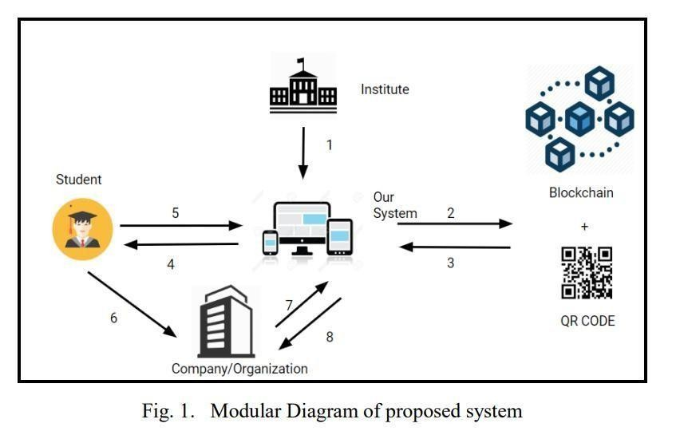
Figure 5.1: Modular diagram of proposed system
The system follows a client–server architecture integrated with blockchain technology.
It consists of four major layers: the User Interface Layer, Application Layer, Data Storage Layer, and Blockchain Layer.
The User Interface Layer provides web-based interfaces for institutes, students, and external verifiers. Institutes can log in to upload Excel files for bulk certificate generation, while students can view and download their certificates. Verifiers can authenticate certificates using a unique hash or QR code.
The Application Layer acts as the core processing unit of the system. It handles user authentication, role-based access control, certificate generation, hash computation, QR code creation, and verification logic. When an institute uploads an Excel file, the backend processes each record, generates a cryptographic hash, creates a PDF certificate, and generates a QR code linked to the verification URL.
The Data Storage Layer uses a relational database (SQLite/MySQL) to store user credentials, certificate metadata, hash values, and file paths. This ensures efficient querying, duplicate prevention, and secure data management.
The Blockchain Layer stores the unique certificate hash on the blockchain, ensuring immutability and transparency. Any attempt to tamper with certificate data results in a hash mismatch, thereby preventing fraud. The blockchain acts as a decentralized trust layer for certificate validation.
Overall, the architecture ensures secure certificate issuance, decentralized verification, and seamless interaction between system components.
5.1.2 Modules
The system is divided into several functional modules, each responsible for a specific operation within the certificate lifecycle. The Authentication Module manages user registration and login with role-based access for institutes and students. The Institute Module enables institutions to upload Excel files, generate certificates in bulk, create QR codes, and store certificate hashes securely. The Certificate Generation Module processes student data, generates PDF certificates, computes cryptographic hash values, and links certificates with QR-based verification. The Blockchain Integration Module stores and validates certificate hashes on the blockchain to ensure tamper-proof verification. The Student Module allows students to view, download, and store their issued certificates. Finally, the Verification Module enables any external authority to verify a certificate using a hash or QR code, ensuring instant and trusted authentication without intermediaries.

5.2.1 Authentication and User Management Module
This module is responsible for managing user registration, login, and role-based access control within the system. It supports two primary user roles: Institute and Student. Secure authentication ensures that only authorized institutes can generate and issue certificates, while students can access only their own certificates. This module enhances system security by preventing unauthorized access and maintaining proper user privileges.
5.2.2 Certificate Generation and Management Module
This module handles the bulk generation of digital certificates using Excel input files uploaded by institutes. For each student record, the system generates a unique cryptographic hash, creates a tamper-proof PDF certificate, and generates a corresponding QR code for verification. The module also ensures duplicate prevention by validating hash uniqueness before storing certificate data.
5.2.3 Blockchain Storage and Verification Module
This module integrates blockchain technology to ensure the immutability and authenticity of certificates. The unique hash of each generated certificate is stored on the blockchain, making it impossible to alter certificate details without detection. During verification, the stored blockchain hash is compared with the provided certificate hash to confirm authenticity, ensuring trust and transparency in the verification process.
5.2.4 Certificate Access and Verification Module
This module enables students and external verification authorities to view and verify certificates. Students can securely access, download, and store their certificates through the student dashboard. Verification authorities can authenticate certificates by entering the certificate hash manually or by scanning the QR code, which redirects to the verification page and displays certificate validity instantly.
5.1.3 Algorithm
The algorithm describes the step-by-step procedure followed by the Block chain Based Digital Certificate Generation and Verification System to generate, store, and verify digital certificates securely.
Algorithm: Blockchain-Based Digital Certificate Generation and Verification
Input:
Excel file containing student details (Student ID, Name, Email, Course, Institution, Issue Date)
Output:
Digitally signed certificate with unique hash, QR code, and verification status
Steps:
- Start the system and initialize the database and blockchain connection.
- User selects role (Institute or Student) and logs into the system using valid credentials
- If the user role is Institute, allow access to the certificate generation dashboard.
- Institute uploads an Excel file containing multiple student records.
- For each record in the Excel file:
- Read student details.
- Concatenate relevant fields to form certificate data.
- Generate a cryptographic hash (SHA-256) for the certificate data.
- Check whether the generated hash already exists in the database.
- If the hash exists, skip certificate generation for that record.
- If the hash does not exist:
- Generate a PDF certificate.
- Generate a QR code embedding the verification URL.
- Store certificate metadata and hash in the database.
- Store the certificate hash on the blockchain.
- Display the number of certificates successfully generated and skipped.
- If the user role is Student, allow access to view and download assigned certificates.
For certificate verification:
- User enters the certificate hash manually or scans the QR code.
- System retrieves the corresponding record from the database.
- Verify the hash against the blockchain-stored value.
- If the hash matches, display certificate details as valid.
- If the hash does not match, display verification failure.
- End the process.
Algorithm Characteristics
- Ensures uniqueness using cryptographic hash values
- Prevents duplicate certificate generation
- Enables fast and secure verification using QR codes
- Provides tamper-proof validation through blockchain storage
5.1.4 Uml Diagrams
Unified Modeling Language (UML) diagrams are used to visually represent the structure and behavior of the Blockchain-Based Digital Certificate Generation and Verification System. UML provides a standardized way to model system components, their relationships, and interactions in a clear and understandable manner. These diagrams help in analyzing system requirements, designing software architecture, and improving communication among developers and stakeholders.
In this project, UML diagrams are used to illustrate how users interact with the system, how internal modules communicate with each other, and how data flows during certificate generation and verification. The use of UML enhances system clarity, reduces design complexity, and ensures that the implementation aligns with the intended system design.
5.1.4.1 Introduction to Uml Diagrams
Unified Modeling Language (UML) is a standardized visual modeling language used to specify, visualize, construct, and document software systems. It is widely adopted in software engineering to represent both the structural and behavioral aspects of a system.
UML diagrams provide a graphical representation of system components such as classes, objects, actors, and their interactions. By using UML, complex system functionalities can be simplified into understandable models, making it easier to design, implement, and maintain software applications. UML also supports better requirement analysis and reduces ambiguity during the development process.
In the Blockchain-Based Digital Certificate Generation and Verification System, UML is utilized to model user roles, certificate generation workflows, verification processes, and interactions between the application layer, database, and blockchain components. This ensures a well-organized and scalable system design.
Role of Uml in OO Design
UML is a modeling language used to model software and non-software systems. Although UML is used for non-software systems, the emphasis is on modeling OO software applications. Most of the UML diagrams discussed so far are used to model different aspects such as static, dynamic, etc. Now whatever be the aspect, the artifacts are nothing but objects.
Hence, the relation between OO design and UML is very important to understand. The OO design is transformed into UML diagrams according to the requirement. In this project ,basic UML diagrams have been explained
1) Use Case Diagram
2) Class Diagram
3) Sequence Diagram
4) Collaboration Diagram
5) Activity Diagram
6) Deployment Diagram
5.1.4.2 Class Diagram
UML class diagrams model static class relationships that represent the fundamental architecture of the system. Note that these diagrams describe the relationships between classes, not those between specific objects instantiated from those classes. Thus the diagram applies to all the objects in the system. A class diagram consists of the following features:
- Classes: These titled boxes represent the classes in the system and contain information about the name of the class, fields, methods and access specifies. Abstract roles of the Class in the system can also be indicated
- Interfaces: These titled boxes represent interfaces in the system and contain information about the name of the interface and its methods. Relationship Lines that model the relationships between classes and interfaces in the system.
- Dependency: A dotted line with an open arrowhead that shows one entity depends on the behavior of another entity. Typical usages are to represent that one class instantiates an
5.1.5.2 Class Diagram :
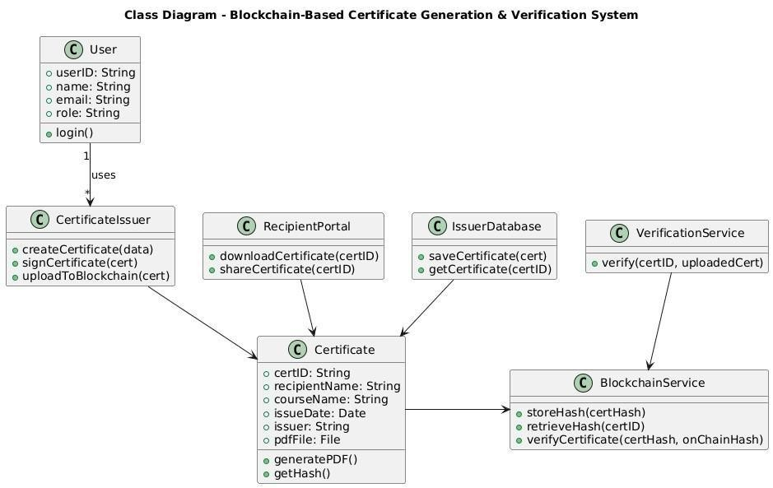
Figure 5.2 Class diagram

5.1.5.3 Use case Diagram
A use case diagram in the Unified Modelling Language (UML) is a type of behavioural diagram defined by and created from a Use-case analysis. Its purpose is to present a graphical overview of the functionality provided by a system in terms.
A use case is a methodology used in system analysis to identify, clarify, and organize system requirements. The use case is made up of a set of possible sequences of interactions between systems and users in a particular environment and related to a particular goal. It consists of a group of elements (for example, classes and interfaces) that can be used together in a way that will have an effect larger than the sum of the separate elements combined. The use case should contain all system activities that have significance to the users. A use case can be thought of as a collection of possible scenarios related to a particular goal, indeed, the use case and goal are sometimes considered to be synonymous. The main purpose of a use case diagram is to show what system functions are performed for which actor. Roles of the actors in the system can be depicted.
Parts of Use Case Diagram System boundary boxes (optional)
A rectangle is drawn around the use cases, called the system boundary box, to indicate the scope of system. Anything within the box represents functionality that is in scope and anything outside the box is not Relationships.
Include
In one form of interaction, a given use case may include another. "Include is a Directed Relationship between two use cases, implying that the behavior of the included use case is inserted into the behavior of the including use case”.
The first use case often depends on the outcome of the included use case. This is useful for extracting truly common behaviours from multiple use cases into a single description. The notation is a dashed arrow from the including to the included use case, with the label "«include»". This usage resembles a macro expansion where the included use case behavior is placed inline in the base use case behavior. There are no parameters or return values. To specify the location in a flow of events in which the base use case includes the behavior of another, you simply write include followed by the name of use case you want to include, as in the following flow for track order.
Extend
In another form of interaction, a given use case (the extension) may extend another. This relationship indicates that the behavior of the extension use case may be inserted in the extended use case under some conditions. The notation is a dashed arrow from the extension to the extended use case, with the label "«extend»". The notes or constraints may be associated with this relationship to illustrate the conditions under which this behavior will be executed. Modelers use the «extend» relationship to indicate use cases that are "optional" to the base use case. Depending on the modeler’s approach "optional" may mean "potentially not executed with the base use case" or it may mean "not required to achieve the base use case goal".
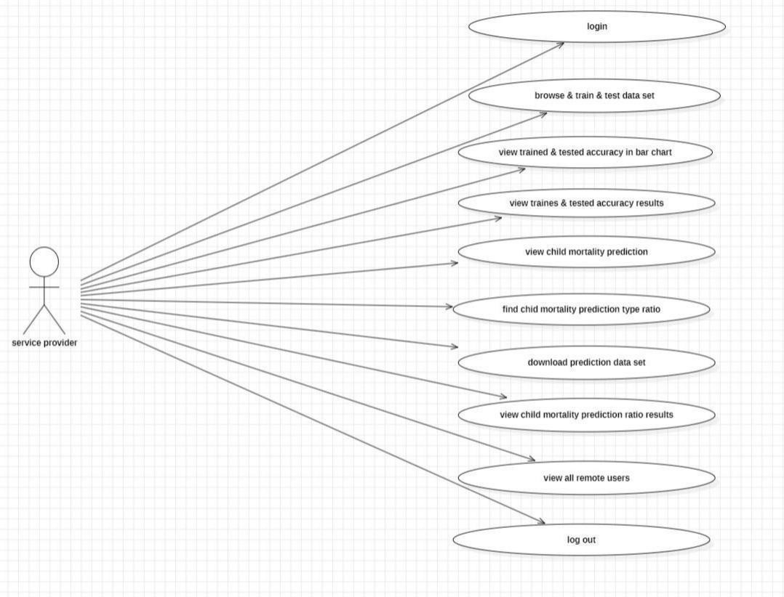
Figure 5.3 Usecase Diagram
5.1.5.4 Sequence Diagram
A sequence diagram in Unified Modelling Language (UML) is a kind of interaction diagram that shows how processes operate with one another and in what order. It is a construct of a Message Sequence Chart. A Sequence diagram depicts the sequence of actions that occur in a system. The invocation of methods in each object, and the order in which the invocation occurs is captured in a Sequence diagram. This makes the Sequence diagram a very useful tool to easily represent the dynamic behavior of a system.
Elements of sequence diagram
The sequence diagram is an element that is used primarily to showcase the interaction that occurs between multiple objects. This interaction will be shown over certain period of time. Because of this, the first symbol that is used is one that symbolizes the object.
Lifeline
A lifeline will generally be generated, and it is a dashed line that sits vertically, and the top will be in the form of a rectangle. This rectangle is used to indicate both the instance and the class. If the lifeline must be used to denote an object, it will be underlined.
Messages
To showcase an interaction, messages will be used. These messages will come in the form of horizontal arrows, and the messages should be written on top of the arrows. If the arrow has a full head, and it’s solid, it will be called a synchronous call. If the solid arrow has a stick head, it will be an asynchronous call. Stick heads with dash arrows are used to represent return messages.
Objects
Objects will also be given the ability to call methods upon themselves, and they can add net activation boxes. Because of this, they can communicate with others to show multiple levels of processing. Whenever an object is eradicated or erased from memory, the "X" will be drawn at the lifeline's top, and the dash line will not be drawn beneath it. This will often occur as a result of a message. If a message is sent from the outside of the diagram, it can be used to define a message that comes from a circle that is filled in. Within a UML based model, a Super step is a collection of steps which result from outside stimuli.
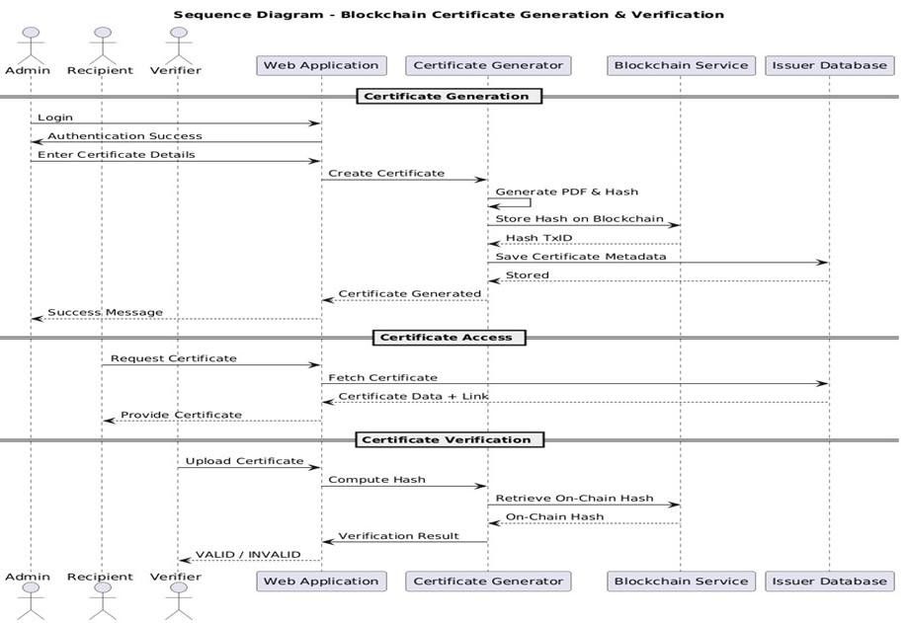
Figure 5.4 Sequence Diagram
5.1.5.5 Activity Diagram
Activity diagram is another important diagram in UML to describe dynamic aspects of the system. Activity diagram is basically a flow chart to represent the flow form one activity to another activity. The activity can be described as an operation of the system. So the control flow is drawn from one operation to another. This flow can be sequential, branched or concurrent. Activity diagrams deals with all type of flow control by using different elements like fork, join etc.
How to draw Activity Diagram?
Activity diagrams are mainly used as a flow chart consists of activities performed by the system. But activity diagram are not exactly a flow chart as they have some additional capabilities. These additional capabilities include branching, parallel flow, swim lane etc. Before drawing an activity diagram we must have a clear understanding about the elements used in activity diagram. The main element of an activity diagram is the activity itself. An activity is a function performed by the system. After identifying the activities we need to understand how they are associated with constraints and conditions. So before drawing an activity diagram we should identify the following elements.
- Activities
- Association
- Conditions
- Constraints
The following are the basic notational elements that can be used to make up a diagram:
Initial state
An initial state represents a default vertex that is the source for a single transition to the default state of a composite state. There can be at most one initial vertex in a region. The outgoing transition from the initial vertex may have a behavior, but not a trigger or guard.
It is represented by Filled circle, pointing to the initial state.
Final state
A special kind of state signifying that the enclosing region is completed. If the enclosing region is directly contained in a state machine and all other regions in the state machine also are completed, then it means that the entire state machine is completed. It is represented by Hollow circle containing a smaller filled circle, indicating the final state.
Rounded rectangle
It denotes a state. Top of the rectangle contains a name of the state. Can contain a horizontal line in the middle, below which the activities that are done in that state are indicated.
Arrow
It denotes transition. The name of the event (if any) causing this transition labels the arrow body.
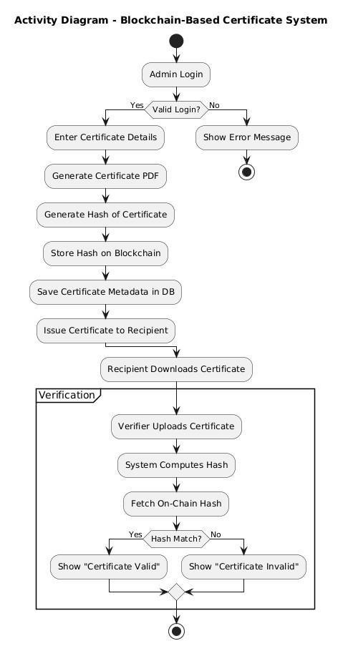
Figure 5.5 Activity Diagram

5.1.5.6 Deployment Diagram
Deployment diagram represents the deployment view of a system .It is related to the Component diagram. Because the components are deployed using the deployment diagrams. A deployment diagram consists of nodes. Nodes are nothing but physical
Hardware’s used to deploy the Applications.
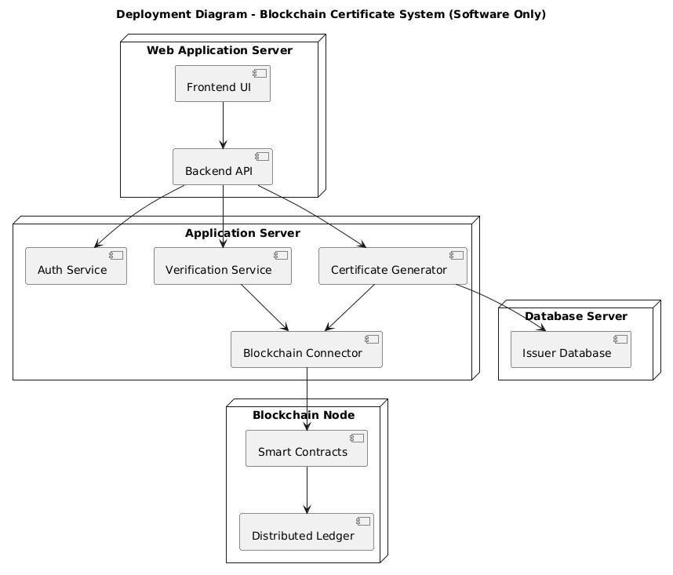
Figure 5.6 Deployment Diagram
5.2 SYSTEM IMPLEMENTATION
The system implementation phase involves translating the proposed system design into a working software solution. This phase focuses on selecting appropriate software tools, defining hardware requirements, and designing an efficient database structure. The Blockchain-Based Digital Certificate Generation and Verification System is implemented using a combination of web technologies, backend frameworks, database systems, and blockchain components to ensure secure, scalable, and reliable certificate management.
5.2.1 Software Description
The software implementation of the system is developed using modern web and backend technologies. The frontend of the application is designed using HTML, CSS, and JavaScript to provide an interactive and user-friendly interface for institutes, students, and verification authorities. Flask, a lightweight Python web framework, is used for backend development due to its simplicity, flexibility, and ease of integration with blockchain and database systems.
Python is used as the core programming language for implementing certificate generation, cryptographic hash computation (SHA-256), QR code generation, and PDF creation. Libraries such as Pandas are used to process Excel files for bulk certificate generation, while Report Lab is used to generate certificate PDFs. QR code generation is implemented using the qrcode library.
For blockchain integration, a smart contract or simulated blockchain module is used to store certificate hash values, ensuring immutability and tamper resistance. FlaskLogin is used for authentication and role-based access control, enabling secure login for institutes and students.
5.2.2 Hardware Description
The hardware requirements for implementing the system are minimal, making it suitable for both academic and real-world environments. The system can be deployed on a standard personal computer or a cloud-based server.
A system with an Intel-based or equivalent processor, a minimum of 8 GB RAM, and sufficient storage (at least 10 GB free space) is adequate for running the application and storing certificates. The system requires a stable internet connection for blockchain interaction and QR-based verification across devices. Mobile devices such as smartphones are used for scanning QR codes to verify certificates, demonstrating cross-platform compatibility.
5.2.3 Database Design
The system uses a relational database to store user information and certificate metadata securely. SQLite is used during development for simplicity, while the system can be extended to use MySQL or PostgreSQL in production environments.
The database consists of tables such as User and Certificate. The User table stores authentication details including email, password, and role (Institute or Student). The Certificate table stores student details, course information, institution name, issue date, unique hash value, and file paths for the generated PDF and QR code.
A unique constraint is applied to the certificate hash value to prevent duplicate certificate generation. The database design ensures efficient querying, data integrity, and secure storage, enabling fast certificate retrieval and verification.
5.2.4 SAMPLE CODE
- Source code
# Initialization and Login Management
login_manager = LoginManager()
login_manager.login_view = "auth.login"
login_manager.init_app(app)
@login_manager.user_loader
def load_user(user_id):
return User.query.get(int(user_id))
app.register_blueprint(auth)
# Database creation
with app.app_context():
db.create_all()
# Main Routes
@app.route("/")
def index():
return render_template("index.html")
@app.route("/institute")
@login_required
def institute_dashboard():
if current_user.role != "institute":
return "Unauthorized Access"
return render_template("institute_dashboard.html")
@app.route("/student")
@login_required
def student_dashboard():
if current_user.role != "student":
return "Unauthorized Access"
certs = Certificate.query.filter_by(email=current_user.email).all()
return render_template("student_dashboard.html", certs=certs)
# Certificate Upload and Generation Logic
@app.route("/upload", methods=["POST"])
@login_required
def upload_excel():
if current_user.role != "institute":
return "Unauthorized Access"
file = request.files["file"]
df = pd.read_excel(file)
created = 0
skipped = 0
for _, row in df.iterrows():
# Data string for hashing
data = f"{row['Student_ID']}{row['Student_Name']}{row['Course']}{row['Issue_Date']}"
hash_val = generate_hash(data)
# Check if certificate already exists
if Certificate.query.filter_by(hash_value=hash_val).first():
skipped += 1
continue
# Generate physical files (PDF and QR)
pdf_path, qr_path = generate_certificate(
row["Student_Name"],
row["Course"],
row["Institution"],
hash_val
)
# Save to Local Database
cert = Certificate(
student_id=row["Student_ID"],
student_name=row["Student_Name"],
email=row["Email"],
course=row["Course"],
institution=row["Institution"],
issue_date=str(row["Issue_Date"]),
hash_value=hash_val,
pdf_path=pdf_path,
qr_path=qr_path
)
db.session.add(cert)
# Blockchain Integration
store_on_blockchain(hash_val)
created += 1
db.session.commit()
return render_template("upload_result.html", created=created, skipped=skipped)
# Verification and Download
@app.route("/verify", methods=["GET", "POST"])
def verify():
cert = None
hash_val = request.args.get("hash")
if hash_val:
cert = Certificate.query.filter_by(hash_value=hash_val).first()
if request.method == "POST":
hash_val = request.form["hash"]
cert = Certificate.query.filter_by(hash_value=hash_val).first()
return render_template("verify.html", cert=cert)
return render_template("verify.html", cert=cert)
@app.route("/download/<filename>")
@login_required
def download_certificate(filename):
return send_from_directory(CERT_PDF_DIR, filename, as_attachment=True)
# Application Runner
if __name__ == "__main__":
app.run(host="0.0.0.0", port=5000, debug=True)
# Blockchain Logic Placeholders
def store_on_blockchain(hash_value):
print(f"Stored on blockchain: {hash_value}")
def verify_on_blockchain(hash_value):
return True
<!DOCTYPE html>
<html lang="en">
<head>
<meta charset="UTF-8">
<title>Blockchain Certificate System</title>
<meta name="viewport" content="width=device-width, initial-scale=1.0">
<style>
* { margin: 0; padding: 0; box-sizing: border-box; font-family: "Segoe UI", Arial, sans-serif; }
body {
min-height: 100vh;
background: linear-gradient(135deg, #1e3c72, #2a5298);
display: flex; align-items: center; justify-content: center;
}
.container {
width: 90%; max-width: 900px; background: #ffffff;
padding: 40px; border-radius: 12px; text-align: center;
box-shadow: 0 15px 40px rgba(0,0,0,0.25);
}
h1 { font-size: 2rem; margin-bottom: 10px; color: #1e3c72; }
.subtitle { color: #555; margin-bottom: 30px; font-size: 1rem; }
.card { display: flex; justify-content: center; gap: 15px; margin-bottom: 35px; flex-wrap: wrap; }
.btn {
text-decoration: none; padding: 12px 24px; border-radius: 6px;
font-weight: 600; transition: all 0.3s ease; cursor: pointer;
}
.btn-primary { background: #1e3c72; color: #fff; }
.btn-secondary { background: #2a5298; color: #fff; }
.btn-outline { border: 2px solid #1e3c72; color: #1e3c72; background: transparent; }
.btn:hover { transform: translateY(-2px); opacity: 0.9; }
.features { display: grid; grid-template-columns: repeat(auto-fit, minmax(180px, 1fr)); gap: 15px; margin-bottom: 30px; }
.feature-box { padding: 15px; background: #f4f7fb; border-radius: 8px; font-weight: 600; color: #1e3c72; }
footer { margin-top: 20px; font-size: 0.85rem; color: #777; }
</style>
</head>
<body>
<div class="container">
<h1>Blockchain-Based Digital Certificate System</h1>
<p class="subtitle">Secure • Tamper-Proof • Instant Verification using Blockchain Technology</p>
<div class="card">
<a href="{{ url_for('auth.login') }}" class="btn btn-primary">Login</a>
<a href="{{ url_for('auth.signup') }}" class="btn btn-secondary">Signup</a>
<a href="/verify" class="btn btn-outline">Verify Certificate</a>
</div>
<div class="features">
<div class="feature-box">🔒 Secure Storage</div>
<div class="feature-box">⛓️ Blockchain Verified</div>
<div class="feature-box">📄 Bulk Certificate Generation</div>
<div class="feature-box">📲 QR Code Verification</div>
</div>
<footer>
<p>© 2025 Blockchain Certificate System | Academic Project</p>
</footer>
</div>
</body>
</html>
5.3 SYSTEM TESTING
System testing is a critical phase in the software development life cycle that ensures the implemented system functions correctly according to the specified requirements. In the Blockchain-Based Digital Certificate Generation and Verification System, systematic testing is performed to validate the correctness, security, and reliability of certificate generation, storage, and verification functionalities. The testing process helps identify defects, ensure data integrity, and confirm that the system performs as expected under different scenarios.
5.3.1 Software Testing

Introduction
Software testing is carried out to verify that each component of the system performs its intended function without errors. The testing process ensures that user authentication, certificate generation, QR code verification, blockchain hash storage, and database operations work correctly. Both manual and functional testing approaches are used to test different user roles such as institute and student. Proper testing guarantees that the system is robust, secure, and ready for real-world usage.
5.3.2 Types of Types
Different testing methodologies are applied to validate the system at various levels of development. These testing types ensure that individual modules work correctly and that the integrated system meets user requirements.
5.3.2.1 Unit Testing
Unit testing focuses on testing individual modules of the system independently. Each function such as user authentication, hash generation, QR code creation, PDF certificate generation, and Excel file processing is tested separately. This type of testing ensures that each module produces the correct output for a given input. Errors detected at this stage are easier to identify and fix, improving overall system reliability.
5.3.2.2 Integration Testing
Integration testing verifies the interaction between different modules of the system. In this project, integration testing ensures that the frontend interfaces communicate correctly with backend services, the database stores and retrieves certificate data accurately, and the blockchain module correctly records and validates hash values.
This testing confirms that combined system components work together seamlessly.
5.3.2.3 Acceptance Testing
Acceptance testing is performed to validate whether the system meets user expectations and functional requirements. This testing is carried out from the end-user perspective, including institute users uploading Excel files, students viewing certificates, and external users verifying certificates using QR codes or hash values. Successful acceptance testing confirms that the system is ready for deployment and real-world usage.
5.3.3 Test Cases
Test cases are designed to verify system functionality under various conditions. Each test case includes input conditions, expected results, and actual outcomes. Examples of test cases include verifying login credentials, uploading valid and invalid Excel files, generating certificates, preventing duplicate certificates, scanning QR codes, and validating incorrect hash values. All test cases are executed successfully, ensuring that the system behaves as expected.

CHAPTER 6
RESULTS
The results obtained from implementing the Blockchain-Based Digital Certificate Generation and Verification System demonstrate that the system effectively addresses certificate forgery and verification challenges. The system successfully generates digital certificates in bulk, assigns unique cryptographic hash values, and enables instant verification through QR codes and hash-based validation.
6.1 EXECUTION PROCEDURE
The execution procedure begins with launching the Flask-based web application and initializing the database. Institute users log in and upload Excel files containing student data, after which certificates are generated automatically. The system creates PDF certificates, generates QR codes, stores certificate details in the database, and records hash values on the blockchain. Students log in to view and download certificates, while verification authorities validate certificates using QR codes or hash values.
6.2. SCREENSHOTS
Screenshots are captured at various stages of system execution to demonstrate functionality. These include the home page, login and signup pages, institute dashboard, Excel upload interface, certificate generation results, student dashboard, QR code verification page, and certificate validation output. The screenshots provide visual evidence of successful system operation.
Additional screenshots of the student dashboard, QR code verification page, and certificate validation output illustrate secure certificate access and successful verification. Together, these screenshots provide clear visual evidence of correct system operation and reliability.
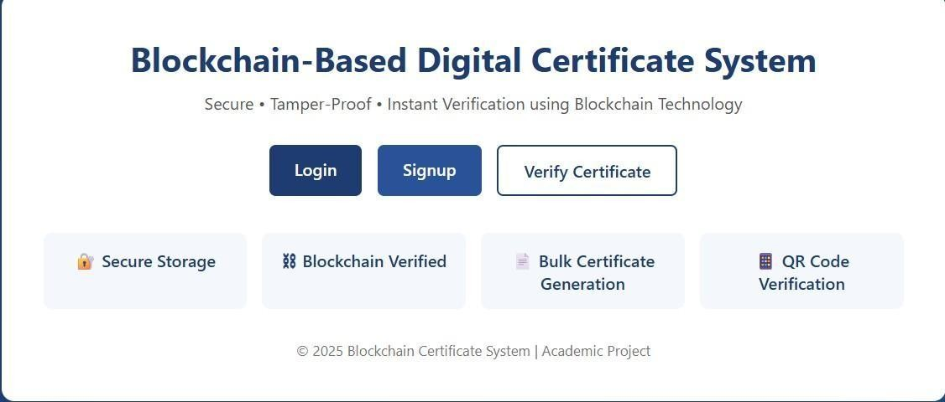
Figure 6.1 User Registration
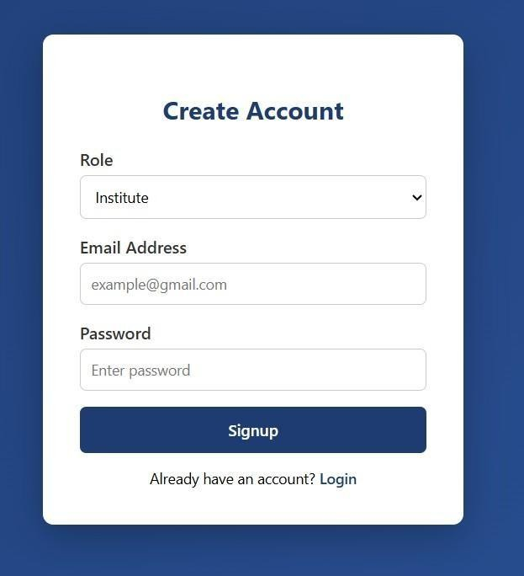
Figure 6.2 User Login


Figure 6.3 User Login
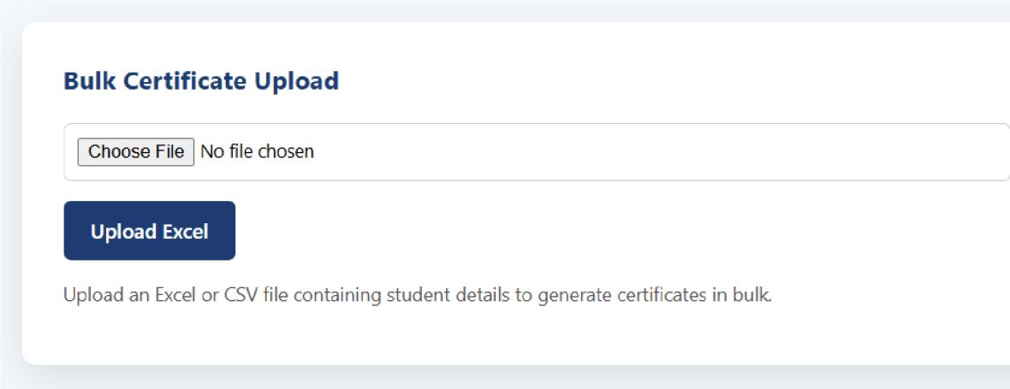
Figure 6.4 Bulk Certificate Upload

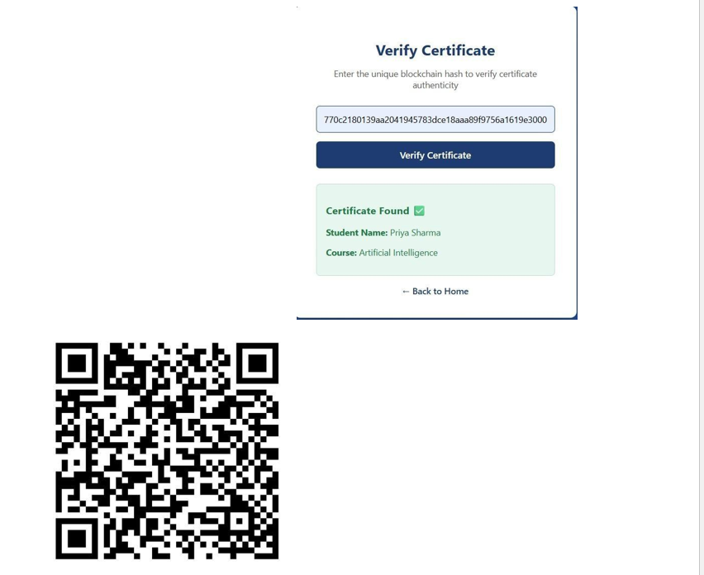
Figure 6.5 Certificate Verification And QR Generation

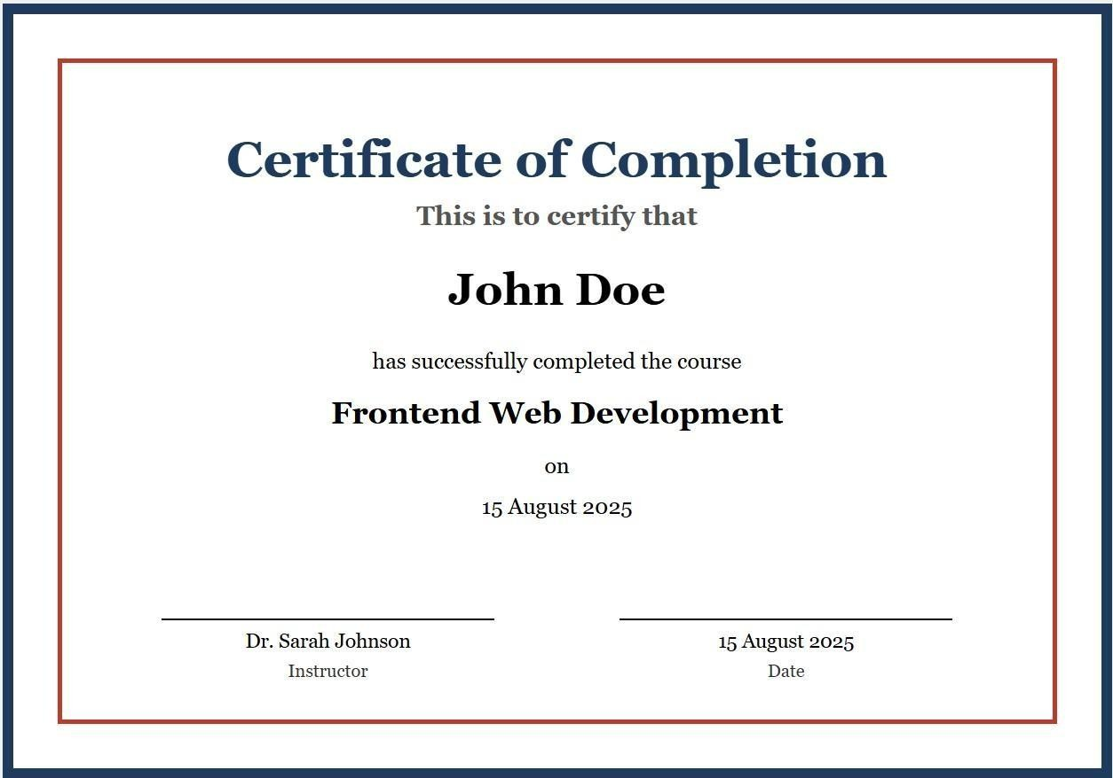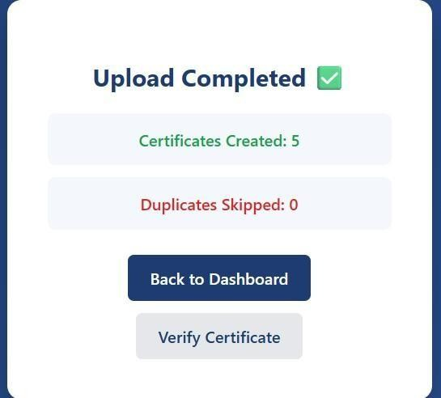

Figure

7

Figure 6.6 Certificate Download And Verified

CHAPTER 7
CONCLUSION AND FUTURE ENHANCEMENT
7.1 CONCLUSION
The Blockchain-Based Digital Certificate Generation and Verification System provides a secure, efficient, and tamper-proof solution for issuing and verifying academic certificates. By leveraging blockchain technology, cryptographic hashing, and QR-based verification, the system eliminates certificate forgery and reduces verification delays. The system is scalable, user-friendly, and suitable for educational institutions and organizations seeking secure digital certification solutions.
7.2 FUTURE ENHANCEMENTS
Future enhancements can further improve the system’s functionality and scalability. Possible improvements include deploying the system on a public blockchain network, integrating MetaMask for real-time blockchain transactions, implementing cloudbased storage for certificates, adding certificate revocation mechanisms, and developing a mobile application for easier access and verification. These enhancements will make the system more robust and suitable for large-scale adoption.

REFERENCES
[1] Satoshi Nakamoto, Bitcoin: A Peer-to-Peer Electronic Cash System, 2008.
[2] Melanie Swan, Blockchain: Blueprint for a New Economy, O’Reilly Media, 2015.
[3] W3C, Web Application Security Standards.
[4] Flask Documentation, https://flask.palletsprojects.com IEEE [5] Xplore Digital Library.
[5] A. M. Tawfik, A. Al-Ahwal, A. S. T. Eldien, and H. H. Zayed, “Blockchain-based access control and privacy preservation in healthcare: A comprehensive survey,” Cluster Computing, vol. 28, p. 529, 2025, doi: 10.1007/s10586-025-05308-x.
[6] C. Regueiro and B. Urquizu, “Blockchain-based evidence trustworthiness system in certification,” Journal of Cybersecurity and Privacy, vol. 5, 2025, doi:
10.3390/jcp5010001.
I. Gligorea, M. Cioca, R. Oancea, A.-T. Gorski, H. Gorski, and P. Tudorache, “Adaptive learning using artificial intelligence in e-learning: A literature review,” Education Sciences, vol.
13, 2023, doi: 10.3390/educsci13121216.
[7] A. S. Alammary, “Building a sustainable digital infrastructure for higher education: A blockchain-based solution for cross-institutional enrollment,” Sustainability, vol. 17, 2025, doi: 10.3390/su17010194.
F. Forsby, M. Furuhed, P. Papadimitratos, and S. Raza, “Lightweight X.509 digital certificates for the Internet of Things,” in Interoperability, Safety and Security in IoT, 2018.
Z. Xu, H. Lin, and M. Wu, “A course recommendation algorithm for a personalized online learning platform for students from the perspective of deep learning,” International Journal of Information Technology and Web Engineering, vol. 18, 2023, doi: 10.4018/IJITWE.333603.
[8] S. Bhaskaran, R. Marappan, and B. Santhi, “Design and analysis of a cluster-based intelligent hybrid recommendation system for e-learning applications,” Mathematics, vol.
9, 2021, doi: 10.3390/math9020197.
J. Wang, H. Xie, F. L. Wang, L.-K. Lee, and O. T. S. Au, “Top-N personalized recommendation with graph neural networks in MOOCs,” Computers and Education: Artificial Intelligence, vol.
2, p. 100010, 2021, doi: 10.1016/j.caeai.2021.100010.

